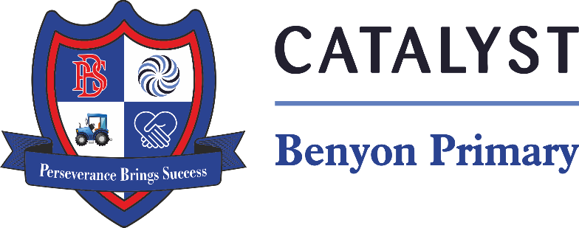

Tyssen Place, South Ockendon, Essex RM15 6PG
Telephone: 01708 853200 E-mail: admin.bps@catrust.org.uk

SEN/Learning Support Assistant
Start Date: Immediate
Working Weeks: 38 – Term Time Only.
Working pattern: Monday to Friday, 8.30am-3.30pm
Working pattern: EYFS - Monday to Friday, 8.00am-4.00pm, 37 hours (unpaid 30 minute break)
Salary: Catalyst Pay Scale Band TLW/A – Point TLW – 4
Closing date: Friday 28th March - Midday
Interview: Wk Beg 31st March

We are looking for valuable new members to join our team who are genuinely motivated by the desire to make a positive difference to pupils’ lives.
The successful candidate will support a child with special educational needs and provide general class support.
We require a committed, enthusiastic learning support assistant who:
- has experience of working with SEND pupiIs in a school setting
- has experience of working with children with additional medical needs
- Works well within a team
- has good verbal and written communication skills
- is patient and resilient with a positive nature
- is able to challenge and motivate all children to succeed
- has high expectations of self and others
- is self-motivated, resilient and able to use their own initiate
- is an adaptable team player with a good sense of humour
- has a love of learning and is committed to their own development

In return we offer:
- a committed team who genuinely want the best for our pupils
- excellent professional development opportunities
- strong, collaborative partnerships with other local schools
- an employee assistance programme
- You will also be added to our "Catalyst Employee Perks" platform where you will be able to access a range of discounts from regular supermarkets, numerous retailers, family days out, restaurants and more.

Our school motto is ‘Perseverance Brings Success’; with your help we will achieve the success of which we are capable.
To apply please go to www.benyonprimaryschool.org.uk or www.essexschoolsjobs.co.uk. Informal visits are warmly welcomed or for an informal, confidential discussion please contact Samantha Oxley, Head of School on 01708 853200

Benyon Primary School is part of Catalyst Academies Trust, an innovative, charitable organisation, whose mission is to widen access to outstanding educational provision by supporting and empowering teachers and leaders in other schools to develop remarkable teaching and achievement outcomes.

Catalyst Academies Trust and Benyon Primary School are committed to safeguarding and protecting the welfare of children and expect staff and volunteers to share this commitment. We follow safer recruitment practices, and all appointments are subject to satisfactory references, pre-employment

