Job Ref No. ECC2662-280
Position Start Date: 01/09/2025
Application Close: 30/08/2025 Midnight
Position Type: Teaching/Child Support

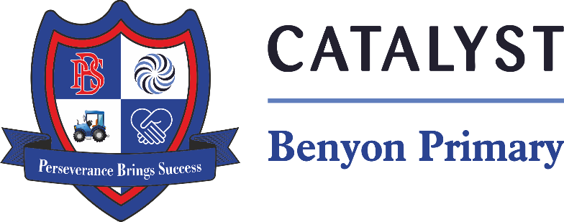
Teaching Assistant Apprentice
Benyon Primary School, South Ockendon
Contract Type: Full-time
Date of Interviews: Arranged when necessary
Pay Range: £12,794
Contract Term: Permanent

Job Description

This is a fantastic opportunity for applicants to train as a Level 3 Teaching Assistant Apprentice. This is an advanced pathway for those who already work in school or who are interested in working with children. This could also be the first step in your journey to being an amazing teacher!
The course is two academic years (18-24 months) and at the end of it you will have gained a Teaching Assistant Apprenticeship. This could lead to the following roles:
- Teaching Assistant
- HLTA
- Foundation degree
- BA (Hons)
- Qualified Teacher Status
Who is suitable for an apprenticeship?
Employers will be particularly interested in applicants who have a keen interest in providing excellent support within a school environment and working as part of a team. You should be able to demonstrate excellent literacy, numeracy and ICT skills. Potential candidates are expected to have achieved GCSE A-C or 9-5 in English, maths and a science subject.
Will I get paid as an apprentice?
Yes, your employer will pay you at least £7.55 (April 2025) per hour in your first year for at least 30 hours per week (college day included) for 52 weeks of the year. They must also allow you to take at least 28 days per year annual leave, including bank holidays, and pay you for it.
How is the Apprenticeship Assessed?
Your assessor will visit you within the workplace to assess your progress and you will attend college for 1 day per week. You will develop your skills and knowledge whilst on and off the job and will receive regular supervision and mentoring from your employer.
What could this Apprenticeship lead to?
This apprenticeship will provide you with the knowledge, understanding and professional skills you can use in your current/future career within education. On completion you can move on in your vocational field into Senior Teaching Assistant level roles or progress onto a Foundation Degree followed by a BA Hons and then eventually Qualified Teacher Status. This progression is a partnership between Chelmsford College, Canterbury Christ Church University and Anglia Ruskin University. There is no obligation for your school to continue your employment once your apprenticeship is complete.
What are the costs?

There are no costs to the apprentice to complete this apprenticeship programme, costs will be incurred if apprentices go on to complete a foundation degree, BA Hons and eventually QTS if they chose to train to become a qualified teacher. The apprentice therefore may need to take out a small student loan to cover these expenses.
Can I complete this qualification without being an apprentice?
Yes, for those aged 19+, this would be assessed in the workplace without college day release. A work based tutor would make visits to you every 3 - 5 weeks to set you course work and observe you work within a classroom environment. The cost of the course is £1,800 with at least 10 hours per week work or voluntary service.
How do I apply?
All apprentices must have employment to complete an apprenticeship, for help with employment and to find out more, telephone David Cornwell on 01245 293119 or e-mail cornwelld@chelmsford.ac.uk.
You can also contact Andrea Parfett at Dilkes Academy for more information: andrea.parfett@catrust.org.uk
You should search for our apprenticeship on the following website: Find an apprenticeship - GOV.UK (www.gov.uk)

Information about the School

Our pupils are aged 3 – 11, ranging from Nursery to Year 6, and mainly live in the area surrounding the school.
At Dilkes we want our children to be happy, confident and to share a passion for learning. We help them to achieve highly and make outstanding progress.
We value every child and ensure that we foster the individuality of their interests and experiences. Our bespoke curriculum is carefully planned to enable us to teach all the National Curriculum subjects in a creative and inspiring way. We engage children in a range of activities that enable them to develop their knowledge and skills, and equip them for life beyond school.
We are very proud of the achievements of our pupils, and this pride is echoed by the pupils themselves. We strive to continue to build on the outstanding provision that Dilkes Academy offers.
"We strive to ensure high achievement and a happy educational experience for every child."

All appointments are subject to safer recruitment requirements to ensure the safeguarding of children and young people. All positions will involve appropriate checks and clearances.

Information about the school Contact Information
Mrs S Oxley
Head of School
Tyssen, South Ockendon Essex, RM15 5PG
Telephone: 01708 853200
Email: sbm.bps@catrust.org.uk

