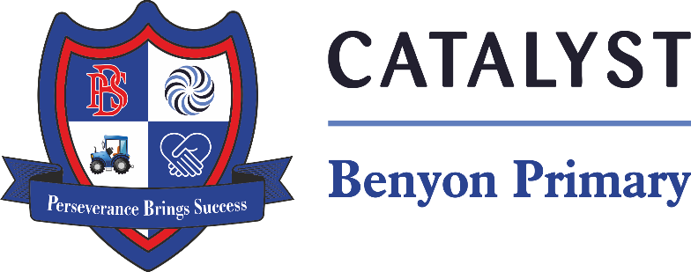

Tyssen Place, South Ockendon, Essex RM15 6PG
Telephone: 01708 853200 E-mail: admin.bps@catrust.org.uk

Dear Parents/Carers,
We are excited to inform you that Year 6 will be visiting the Ragged School Museum as part of our History topic on the Victorians. This trip will take place on Friday, 10th January, and will offer the children an immersive experience, allowing them to gain a deeper understanding of what life was like for children during the Victorian era. It promises to be a fun and educational day that will bring our learning to life!
We will be leaving school promptly at 9:00 am and aim to return in time for normal collection at the end of the school day. Your child will need to bring a packed lunch and a water bottle, as there will be no facilities to purchase food on site. If your child is entitled to free school meals and you would like the school to provide a packed lunch, please let us know.
The cost of the trip will be £21 per pupil, which covers entry to the museum, activities, and transport. Payments can be made on Arbor by Friday, 9th December. If you have any concerns regarding payment, please do not hesitate to contact the school office.
We are also looking for a few parent helpers to assist on the day. If you are available and would like to join us, please indicate your interest on the permission slip or contact the class teacher. Parent helpers are invaluable in ensuring the trip runs smoothly, and we appreciate your support.
Please return the attached permission slip by Friday, 9th December to confirm your child’s attendance. We look forward to a fantastic day at the Ragged School Museum!
Thank you for your support,
Mrs Martins and Mrs Nicholls

