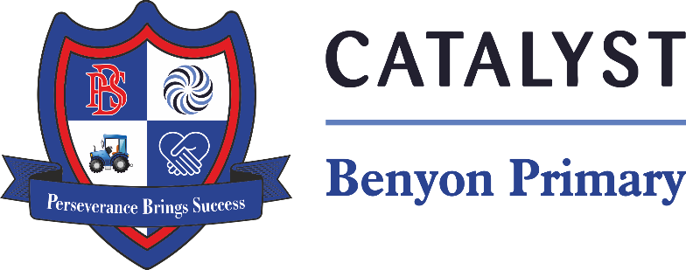

Tyssen Place, South Ockendon, Essex RM15 6PG
Telephone: 01708 853200 E-mail: admin.bps@catrust.org.uk

Friday 21st March 2025

Dear Parents/Carers,

Re: Reception Barleylands Farm Trip
We are very pleased to announce that we have arranged for all reception pupils to attend a trip, to Barleyland Farm on Thursday, 22nd May 2025. To support our topic – Growing, where we will be exploring how different animals, plants and ourselves grow.
The cost of the trip will be £24 per child; this includes the cost of the transport and entrance to Barleyland Farm. If the school is unable to cover the cost of the trip due to a shortfall in payments, the school will cancel the activity and refund parents. All money must be paid by 24th April 2025 via Arbor. If you are finding it difficult to make this payment, please speak with the office to see what other payment arrangements can be made.
Please ensure your child is in school for regular school time, as we plan to leave promptly at the beginning of the school day. We will return to school by the end of the school day. If we are delayed due to traffic, the school office will be informed. Your child must wear school uniform, but can wear comfortable sensible shoes. Please be mindful of the weather and dress your child appropriately; this includes sun cream and sunhats.
Your child will need to bring a healthy packed lunch (please no sweets, chocolates or fizzy drinks). Alternatively, you may wish to order a free school packed lunch. Please email the office on admin.bps@catrust.org.uk There will be no time to visit the gift shops, so please do not send any additional money with your child.
We will need a small number of parent helpers, so please email the school office at admin.bps@catrust.org.uk

Yours sincerely,

Miss Ravindran and Mrs Agoston

