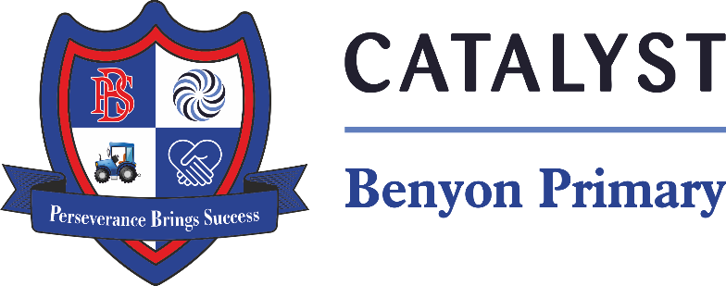

Tyssen Place, South Ockendon, Essex RM15 6PG
Telephone: 01708 853200 E-mail: admin.bps@catrust.org.uk

Dear Parents/Carers,

We are excited to announce that Science Week is fast approaching, taking place from 7th – 16th March 2025! This year’s theme, “Change and Adapt,” will help children explore how living things evolve and adjust to their environments. We have planned an exciting whole-school activity to engage all pupils in creative and scientific thinking, this will take place on Friday 14th March 2025.
In addition to this, we are launching a fun #ScienceSelfie competition to help children recognise that Science is all around us. We encourage pupils to take a selfie while engaging in a Science-related activity at home. Here are a few ideas to inspire them:
- Blowing bubbles
- Planting seeds
- Moving toy vehicles
- Exploring animal habitats
To enter the competition, each child will need to provide a short explanation of the Science behind their selfie. We understand that younger children (Reception and Year 1) may need some assistance, so parents are welcome to help them write their explanation or write it on their behalf.
There will be three prizes awarded for the best entries, and all submissions will be featured in our school newsletter and on the school website. To take part, please email your child’s photo and explanation to admin.bps@catrust.org.uk. Please submit selfies by Monday 17th March 2025.
We are looking forward to seeing all the creative Science selfies!
Miss Spence

