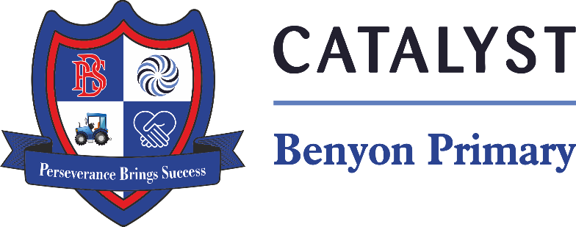

Tyssen Place, South Ockendon, Essex RM15 6PG
Telephone: 01708 853200 E-mail: admin.bps@catrust.org.uk

Dear Parents/Carers, Friday 4th October 2024

We are very pleased to announce that we have arranged for our children to see Snow White at the Thameside Theatre, Grays on Wednesday 11th December 2024. The children will be travelling to the pantomime by train.

The cost of the trip which is being subsidised by the school will be £13.00 per child; this includes the cost of the transport and theatre ticket.
Payment must be made on the Arbor App and will be listed under Trips on the main dashboard by paying you are consenting to your child attending the trip.
Payment must be made by the Monday 2nd December 2024 as we have limited space, tickets will be on a first come, first served basis.
We will be leaving the school at 11:30, therefore the children will have lunch at school at 11am
Children can bring a healthy snack for the interval.
Your child is to wear school uniform and they will need to bring a packed lunch. Alternatively, if your child is entitled to Free School Meals you may wish to order a free school packed lunch, to do so please email us on admin.bps@catrust.org.uk
Yours sincerely

Mrs S Oxley
Head of School

