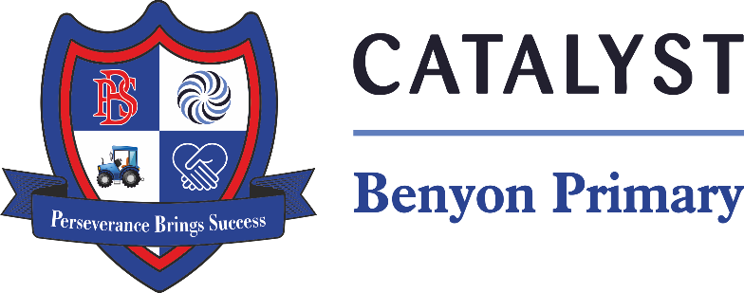

Tyssen Place, South Ockendon, Essex RM15 6PG
Telephone: 01708 853200 E-mail: admin.bps@catrust.org.uk

6th March 2025
Year 4 Anglo Saxon Workshop – Thursday 22nd May 2025
Dear Parents/Carers,
As a way of providing your child with the best opportunity to find out about our topic Anglo Saxons, we have arranged for a company called ‘Hadleigh Histories’ to spend the day with us on Thursday 22nd May 2025.
On the day, your child will learn more about the Anglo Saxons, including looking at artefacts, making a clay pendant, looking at different plants that they used to make dyes, studying clothing and weapons, going to warrior school and taking part in a mock battle, as well as a taking part in an archaeological dig, getting a hands-on experience of what life may have been like thousands of years ago!
This workshop comes highly recommended and will be an enjoyable experience for your child to learn and understand what life was like during this time period.
To enhance the children’s involvement even further, children are encouraged to dress up as someone from the Anglo Saxon period. You can purchase an outfit or even better, make your own using things you already have indoors!
The cost of the experience is £7.50 per child. This is for the whole day’s experience, which includes the time of the staff and the clay for the children to make clay pots to take home.
To allow your child to participate please make the payment via Arbor before Wednesday 30th April 2025. Unfortunately if not enough money is raised, the workshop will not be able to go ahead.
All money must be paid by Wednesday 30th April 2025 via Arbor. If you are finding it difficult to make this payment, please speak with the office to see what other payment arrangements can be made.

Yours sincerely,
Mr Rix and Miss Begum

