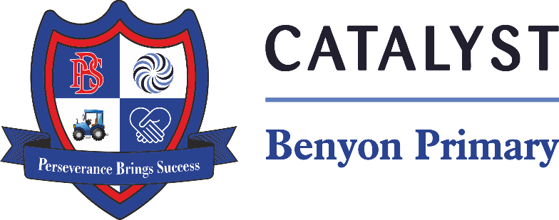

Tyssen Place, South Ockendon, Essex RM15 6PG
Telephone: 01708 853200 E-mail: admin.bps@catrust.org.uk

Buckingham Palace Friday 26th September 2025

Dear Parents and Carers,

We are thrilled to share that our Year 2 children will be visiting Buckingham Palace on Friday 26th September 2025 as part of our topic on the British Royal Family. This is a wonderful opportunity for the children to deepen their learning with a real-life experience at one of the most iconic landmarks in the United Kingdom. This year, we are attending during schools week, which means we can look forward to fewer crowds and more time to explore the palace and its surroundings.

The cost of this trip will be £18.50. Please make payment by Friday 5th September 2025 Payment includes entry to the palace and coach travel. If you need to make an arrangement to pay, please inform the office who can organise this for you.

The coach will be departing promptly at 8:15am, so we kindly ask that all children arrive at school by 7:45am. Unfortunately, we will not be able to delay departure, and children arriving late may be unable to join the trip.

All children will need to bring a packed lunch. If you would like the school to provide one, please inform the school office by Monday 15th September 2025. Children should wear school uniform for the day. However, they may wear trainers for comfort as there will be a lot of walking. Please ensure they bring a light backpack, as they will be carrying their belongings throughout the day.

Please be aware that London traffic can be unpredictable. If there are any delays, we will update you via the school app with an estimated time of arrival.

If you are available and would like to volunteer to support the trip, please let the school office know. Your help is always greatly appreciated.

We look forward to an exciting and memorable day for our Year 2 pupils.

Warm regards,

Year 2 teachers.

